Southern



Irish Terrier Society

PATRON: Mrs L Jackson

Schedule of 12 Class

**OPEN SHOW**

UNBENCHED – SINGLE BREED

*(To be held under Kennel Club Rules & Show Regulations)*

**HELD IN CONJUNCTION WITH**

**BATH CANINE SOCIETY CHAMPIONSHIP SHOW**

**AT THREE SHIRES FIELD, BANNERDOWN, BATH**

**BA1 8EG**

**On Sunday 26TH May 2024**

Show Opens: 07.30 am Judging: Not before 11.30 am

**Judge – Mr Gareth Brown**

The Judge at this show agrees to abide by the following statement:

“In assessing dogs, judges must penalise any features or exaggerations which they consider would be detrimental to the soundness, health and wellbeing of the dog.”

Jurisdiction and Responsibilities

The officers and committee members of the society holding the licence are deemed responsible for organising and conducting the show safely and in accordance with the rules and regulations of The Kennel Club and agree to abide by and adopt any decision of the Board or any authority to whom the Board may delegate its powers subject to the conditions of Regulation F17. In so doing those appointed as officers and committee members accept that they are jointly and severally responsible for the organisation of the show and that this is a binding undertaken (vide Kennel Club General Show Regulations F4 and F5)

Entries to be sent to: Mrs Judy Atkin, 50 Hawkshead Way, Gunthorpe, Peterborough, PE4 7JN

ENTRIES CLOSE: MONDAY, 9th May 2024 (Postmark)

(We strongly advise you use 1st class mail and obtain proof of posting)

(If you require confirmation please enclose a stamped addressed envelope)

~ EXHIBITORS PLEASE NOTE ~

A DOG DOCKED ON OR AFTER 6TH APRIL 2007 MAY NOT BE ENTERED FOR EXHIBITION AT THIS SHOW

PHOTOGRAPHY AND VIDEO RIGHTS

~IMPORTANT NOTICES~

DOGS OR BITCHES WILL BE ACCEPTED AT ANY TIME BUT IT IS THE RESPONSIBILITY OF THE EXHIBITOR THAT EXHIBITS ARE AVAILABLE WHEN REQUIRED

The Organisers would like to bring the regulation on photography and filming to the attention of exhibitors, trade stands, press and visitors. It is a condition of all those attending the event that no filming or other form of recording may be taken or made at the venue without the express written permission of the Organisers. The taking of photographs in the show venue for sale or reward is strictly prohibited except with the written permission of the Organisers. Press accredited photographers are provided with permission to take photographs ONLY for the use in newspapers, magazines and internet sites – this is for news purposes only. There is no objection to the general public taking photographs of general views of the Show, provided that these are for private use. Specific dogs may be photographed only with the approval of the exhibitor. No photographs or filming is permitted in breed judging rings whilst judging is actually taking place. However, judges may allow it to happen at the end of classes or after the Challenge Certificate is awarded. Filming and flash photography is allowed from outside the rings at all times unless the operation of the camera is actually affecting exhibits. However, if a powerful flash unit is used or it is clear that exhibits are being affected, a ring steward or the judge is empowered to stop the person concerned.

C:\Users\IAN\AppData\Local\Microsoft\Windows\Temporary Internet Files\Content.IE5\SU6DRBT2\MC900322642[1].wmf



1

**SOUTHERN IRISH TERRIER SOCIETY**

PATRON: Mrs Lucy Jackson

**CHAIRMAN**: Mr I Bamsey

**SECRETARY**: Mr J Nevill **TREASURER**: Mrs C Bamsey

**COMMITTEE:**

Mrs J Atkin, Miss M Bradshaw,

Mrs J Lamburn, Mrs J Simons, Miss M Ruffles, Miss M Williamson, Mrs S York, Mrs S Mc Connell, Mrs A Karau,

Ms C Chilvers

**~ PRIZES & ROSETTES ON OFFER ~**

**ROSETTES**

• 1ST – 3RD IN EACH CLASS •

**DIPLOMAS**

• BEST IN SHOW •

• BEST OPPOSITE SEX IN SHOW •

• BEST PUPPY IN SHOW •

• BEST VETERAN IN SHOW •

• RESERVE BEST DOG •

• RESERVE BEST BITCH •

• BEST OPPOSITE SEX PUPPY •

BEST BABY PUPPY

**CUPS & TROPHIES**

Please note that Cups & Trophies will

be available this year.

A £10.00 refundable deposit will be

require

**CLASSIFICATION**

**JUDGE – Gareth Brown**

1. VETERAN DOG OR BITCH
2. BABY PUPPY DOG OR BITCH
3. PUPPY DOG 8 PUPPY BITCH
4. JUNIOR DOG 9 JUNIOR BITCH
5. POST GRADUATE DOG 10 POST GRADUATE BITCH
6. LIMIT DOG 11 LIMIT BITCH
7. OPEN DOG 12 OPEN BITCH

**~ SHOW INFORMATION ~**

**ENTRY FEES:**

First Entry @ £8.00 per Dog

All Subsequent Entries @ £3.00 per Dog

**CATALOGUES:** £2.50 **MUST** be pre-paid and ordered on the entry form ONLY A SMALL NUMBER WILL BE AVAILABLE ON THE DAY @ £3.00 EACH

**RULES & REGULATIONS**

1. The Show will open at 7.30 am.
2. Dogs will be received at any time but it is the responsibility of the exhibitor to have exhibits available when required.
3. Judging will not commence before 11:30 am (AFTER COMPLEATION OF THE BREED JUDGING IN THE BATH CHAMPIONSHIP SHOW)
4. Exhibits may be removed from the Show after their judging has been completed. The Show will close half an hour after all judging has been completed.
5. The use of cooking stoves in the proximity of the tenting & benching areas is forbidden except as authorised by the Show Management.
6. **ENTRY FEES.** £8.00 first entry for each dog & £3.00 for subsequent with same dog. Pre-paid catalogues £2.50, £3.00 on the day. Car Park passes will not be sent out; pay-on-the-day must be displayed.
7. Prize Money will NOT be paid at this show.
8. **REFUSAL OF ENTRIES**: The Committee reserves to itself the right to refuse entries or advertisements.
9. **BABY PUPPIES**: A baby puppy is a dog of four and less than six calendar months of age on the first day of the show, not eligible for best dog or Bitch.

3

1. **PUPPIES**: Puppies under six calendar months of age on the first day of the Show are not eligible for exhibition. Puppies aged 4 months and over can be entered **NOT FOR COMPETITION**.
2. **MATING OF BITCHES**: The mating of bitches within the precincts of the Show is forbidden.
3. **BEST PUPPY IN SHOW**: Where a Best Puppy in Show is scheduled the Best Puppy in Show is a puppy which has competed & is unbeaten by any other puppy exhibited at the same Show. A puppy is a dog of six & not exceeding twelve calendar months of age on the first day of the Show. Where the Best of Breed or Best in Show is a puppy it will automatically be Best Puppy in Breed & Best Puppy in Show respectively. Consequently selection of Best Puppy in Breed & Best Puppy in Show must follow the selection of Best of Breed & Best in Show respectively.

4

1. **BEST IN SHOW**: The dog declared Best in Show is a dog which has competed & Unbeaten by any other dog exhibited at the same Show. Best in Show must be selected from the exhibits declared Best of Sex providing they are unbeaten winning dogs. Reserve Best in Show must be selected from the Best Opposite Sex and the Reserve Best of Sex to the exhibit declared Best in Show.

**WITHDRAWAL FROM COMPETITION**: Dogs which become eligible for Best in Show may be withdrawn from all other competition other that Breed classes and Best of Breed prior to the competition for Best in Show as appropriate in order to remain unbeaten. A dog beaten in completion for Best in Show may subsequently be exhibited in all competition for which it was previously eligible. The dogs declared Best in Show & Reserve Best in Show, however, must not compete in any subsequent competition.

4

**PROVISO**: For the purpose of this Regulation, dogs beaten in competition for Stud Dogs, Brood Bitch, Progeny, Brace & Team or a Special Award confirmed to one breed will not be considered to be a beaten dog.

1. Exhibits will not be admitted to Best n Show competition after a period of 10 minutes has elapsed since the announcement that exhibits are required for judging, unless they have been unavoidably delayed by previous judging not being completed on time, and then only with the special permission of the Show Management.
2. **REGULATIONS**: No modification will be made to this schedule except by permission of the General Committee of the Kennel Club, which will be followed by advertisement in the canine press wherever possible.
3. **PREPARATION FOR EXHIBITION**: All exhibitors must be familiar with Kennel Club Regulation F Annex B – Regulations for the Preparation of Dogs for Exhibition.
4. **OVERSEAS EXHIBITS**: All dogs resident outside the UK must be issued with a Kennel Club Authority to Compete number before entry to the show/event can be made. All overseas entries without an authority to Compete number will be returned to the exhibitor/competitor.
5. Your dog is vulnerable and at risk during hot weather and the Kennel Club offers the following guidance to help guide you through the do’s and don’ts traveling to and whilst at KC licensed events.
   1. When traveling to a Show please take a moment to consider whether the route to the show is on a busy holiday route, and leave earlier to avoid increased time in traffic jams.
   2. If your vehicle is not air-conditioned seriously consider whether traveling to the show is a good idea at all.
   3. The vehicle should be as fully ventilated as possible, and plenty of stops should be taken, with lots of water available to drink.
   4. Ensure your dog is not sitting in full sunlight. There should be plenty of free flowing air around the dog.
   5. When at the show, never leave your dog in the vehicle.
   6. Keep the dog in the shade – take your own shade for example a large umbrella and always have plenty of water available to drink so your dog stays well hydrated.
   7. Avoid your dog taking part in unnecessary exertion or from standing in exposed sunlight for extended lengths of time. Remember, if you feel hot your dog is very likely to feel much hotter and dehydrated, and this could lead to dire results. Please look after your dog’s welfare.

**WARNING: IF YOUR DOG IS FOUND TO BE AT RISK FORCIBLE ENTRY TO YOUR VEHICLE MAY BE NECESSARY WITHOUT LIABILITY FOR ANY DAMAGE CAUSED**.

Anyone whose dog is entered at a Kennel Club licensed event should take all reasonable steps to ensure the needs of their dog(s) are met, and should not put a dog’s health and welfare at risk by any action, default, omission or otherwise. Breach of Kennel Club Regulations in this respect may be referred to the General Committee for disciplinary action under Kennel Club Rules & Regulations.

1. **NOT FOR COMPETITION**: Not for Competition entries will be accepted. Details of each dog so entered must be recorded on the entry form and must be Kennel Club registered.
2. **SECTION F11**. **EXHIBITION OF DOGS:**
3. No person shall carry out punitive correction or harsh handling of a dog at any time whilst at the licensed venue, including its environs, car parks and approaches.
4. The owner, exhibitor, handler or other person in charge of a dog at a Kennel Club licensed event must at all times ensure that the dog is kept under proper control whilst and the licensed venue, including its environs, car park and approaches. This regulation applies before (at any time during the set up period at the venue), during the event and afterwards (at any time during the breakdown of the event).

**DEFINITION OF CLASSES**

6

1. In the following definitions a Challenge Certificate includes any Show award that counts towards the title of Champion under the rules of any governing body recognised by the Kennel Club.
2. Wins at Championship Shows in Breed classes where Challenge Certificates are not on offer shall be counted as wins at Open Shows.
3. In the case of a dog owned in partnership and entered in Members’ classes or competing for Members’ Specials each partner must at the time of entry be a member of the Society.
4. In estimating the number of award won all wins up to & including the seventh day before the date of closing of entries shall be counted when entering for any class i.e. **2nd May 2024**.
5. Wins in Variety classes do not count for entry in Breed classes but when entering for Variety classes, wins in both Breed and Variety classes must be counted. A First prize does not include a Special prize of whatever value.
6. If an exhibitor reports before judging of a class or classes that a dog has been entered which is ineligible, the exhibitor may choose one of the following options:-
7. **Withdrawal** – the dog may be withdrawn from competition subject to the conditions of Regulations 9(j) & 20.
8. **Transfer** – If a dog is ineligible for a class or classes as regards its breed, colour, sex, weight or height the Show Secretary shall transfer it to the equivalent class or classes for the correct breed, colour, sex, weight or height and, in the event of there being no equivalent class. Minor Puppy & Puppy excepted to the Open class for the correct breed, colour, sex, weight or height.
9. If an exhibit entered incorrectly in a Minor Puppy class, Puppy class or Junior class, which is over age but under 12 calendar months, 18 calendar months of age or 24 calendar months respectively, the Show Secretary shall transfer the exhibit to the Puppy class, Junior class or Yearling class respectively for the correct breed, colour, sex, weight or height and in the event of there being no Puppy, Junior or Yearling to the Open class for the correct breed, colour, sex, weight or height.
10. For any reason other than above, the Show Secretary shall transfer it to the Open class for the correct breed, colour, sex, weight or height.
11. If an exhibitor arrives late & misses a class, even if it is the only class in which the dog is entered, the dog may ***NOT*** be transferred to any other class.

5

**BABY PUPPIES: For dogs of four months of age and not exceeding 6 calendar on the first day of show.**

6

**MINOR PUPPY:** For dogs of six and not exceeding nine calendar months of age on the first day of the Show.

**PUPPY:** For dogs of six and not exceeding twelve calendar months of age on the first day of the Show.

**JUNIOR:** For dogs of six and not exceeding eighteen calendar months of age on the first day of the Show.

**NOVICE:** For Dogs which have not won a Challenge Certificate or three or more First prizes at Open & Championship Shows (Minor Puppy, Special Minor Puppy, Puppy & Special Puppy classes excepted, whether restricted or not).

**POST GRADUATE:** For dogs which have not won a Challenge Certificate or five or more First prizes at Championship Shows in Post Graduate, Minor Limit, Mid Limit, Limit or Open Classes, whether restricted or not, at Shows where Challenge Certificates were offered for the breed.

**LIMIT:** For dogs which have not become Champions under Kennel Club Regulations or under the rules of any governing body recognised by the Kennel Club or won seven or more First prizes in all at Championship Shows in Limit or Open Classes, confined to the breed, whether restricted or not, at Shows where Challenge Certificates were offered for the breed.

**OPEN:** For all dogs of the Breed for which the class is provided and eligible for entry at this Show.

**VETERAN:** For dogs of not less than seven years of age and over on the 1st day of the Show.

**NOT FOR COMPETITION:** Societies may at their discretion, accept Not For Competition entries. Societies may accept such entries from breeds of dog not included within the title of the Society. Fully vaccinated puppies of 4 calendar months or more may be entered NFC.

**~ IMPORTANT NOTICES ~**

DOGS OR BITCHES WILL BE ACCEPTED AT ANY TIME BUT IT IS THE RESPONSIBILITY OF THE EXHIBITOR THAT EXHIBITS ARE AVAILABLE WHEN REQUIRED

PLEASE ENSURE THAT YOU

EXERCISE DOGS IN THE

PERMITTED AREA AND CLEAN

UP ANY FOULING BY DOGS IN

YOUR CHARGE

7

**REGULATIONS FOR THE PREPARATION OF DOGS FOR EXHIBITION F(B)**

1. These regulations must be observed when a dog is prepared for exhibition and/or exhibited at any Kennel Club Licensed event. Objections may be referred to the General Committee for disciplinary action under these show regulations and/or for disciplinary action under Kennel Club Rule A42.
   1. A dog found to have been exhibited in breach of these regulations will automatically be disqualified from exhibition at the show and from any award gained there.
   2. Unless the exhibitor provides a satisfactory explanation for the dog being exhibited in breach of these regulations he/she may be subject to further penalties of either a fine or as listed under rule A42.2.
   3. No substance which alters the natural colour, texture or body of the coat may be present in the dog’s coat for any purpose at anytime during the show. No substance which alters the natural colour of any external parts of the dog may be present on the dog for any purpose at anytime during the show.
2. Any other substance (other than water) which may be used in the preparation of a dog for exhibition must not be allowed to remain in the coat or on any other part of the dog at the time of exhibition.
3. No act or operation which alters the natural conformation of a dog or any part thereof may be performed except:-
   1. Operations certified to the satisfaction of the General Committee.
   2. The removal of dew claws of any breed.
   3. Operations to prevent breeding provided that such operations are notified to The Kennel Club before neutered dogs are shown.

Nor must anything be done calculated to in the opinion of the General Committee to deceive.

1. The General committee without previous notice may order an examination of any dog or dogs at any Show. Any examination thus ordered will be made by a person having executive authority who shall have a written directive from The Kennel club in their possession. Samples may be taken for further examination and analysis.
2. An individual has the right to lodge an objection to a dog only if he/she is the owner or handler of a dog competing in the same breed or class. An objection may however, be lodged by an official of the Show or by anyone so deputed by The Kennel Club. It will be the responsibility of the individual who lodges the objection of the official (as appropriate) to substantiate the grounds for the objection. The Kennel Club will substantiate the grounds for an objection made on its behalf.

8

1. Any objection by an individual related to an infringement of these Regulations must be made in writing to the Show Secretary at his/her office before the close of the Show and the individual must produce evidence of identity at the time of lodging the complaint.

**NO SMOKING OR VAPING IN THE TENTING AREAS**



Visit our Website for details on membership, show results

And much much more ………

[**www.southernirishterriersociety.co.uk**](http://www.southernirishterriersociety.co.uk)

FURTHER COPIES OF THIS

SCHEDULE AND ENTRY FORM

CAN ALSO BE DOWNLOADED

FROM THE WEBSITE

ALSO FOLLOW US ON

FACEBOOK

The Kennel Club requests that all dogs in soft

cages are **NOT** left unattended at any time,

for safety reasons.

PLEASE NOTE: that all cages/crates

are correctly and clearly labelled with

exhibitors contact information or ring number



9

**NOTICE IS HEREBY GIVEN**

**THAT THE ANNUAL GENERAL MEETING**

**OF THE**

**SOUTHERN IRISH TERRIER CLUB**

Will be held at

Steventon Village Hall, The Green,

Steventon, Oxon. OX13 6RR

On Sunday 1st December 2024

At 10.00 am

**Items for inclusion on the Agenda to be**

**With the Secretary 42 days prior to the meeting**

**REFRESHMENTS**

**Available throughout**

**the day**

10





C:\Users\IAN\AppData\Local\Microsoft\Windows\Temporary Internet Files\Content.IE5\WDJNS82K\MC900293200[1].wmf



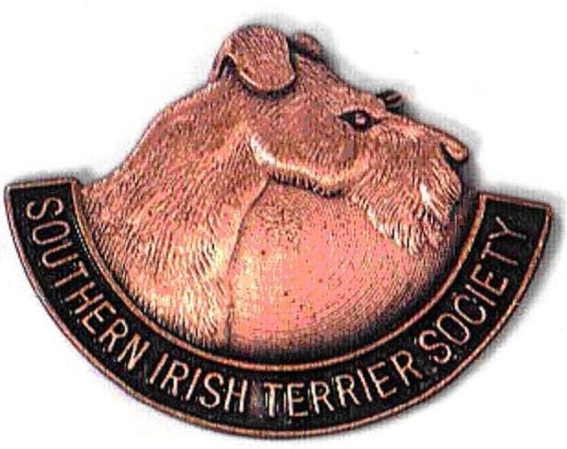

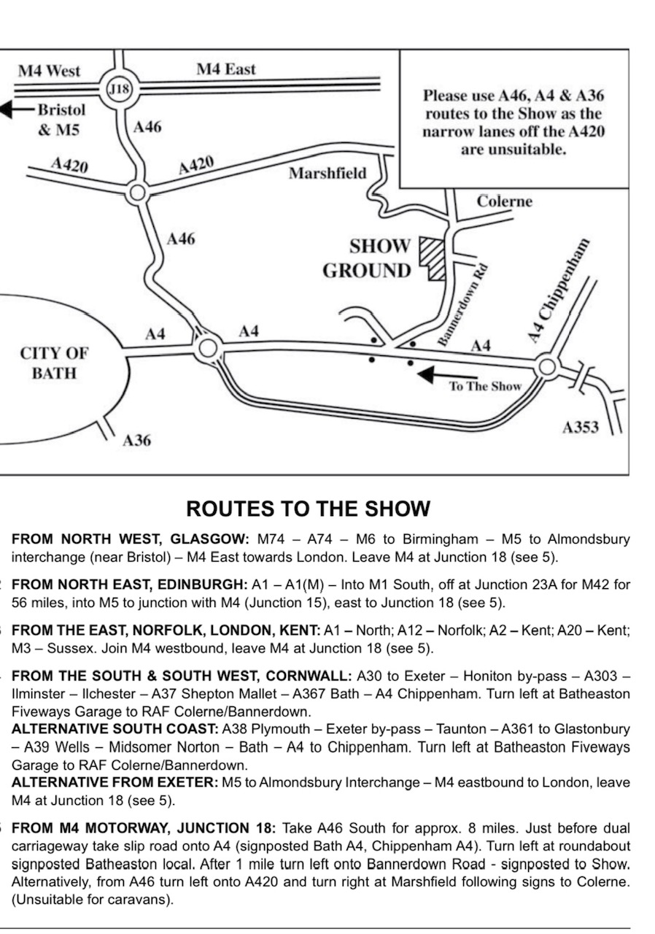



Compiled & Printed by: Mrs C M Bamsey

Tel: 01296 713045 Email: holbam1@gmail.com